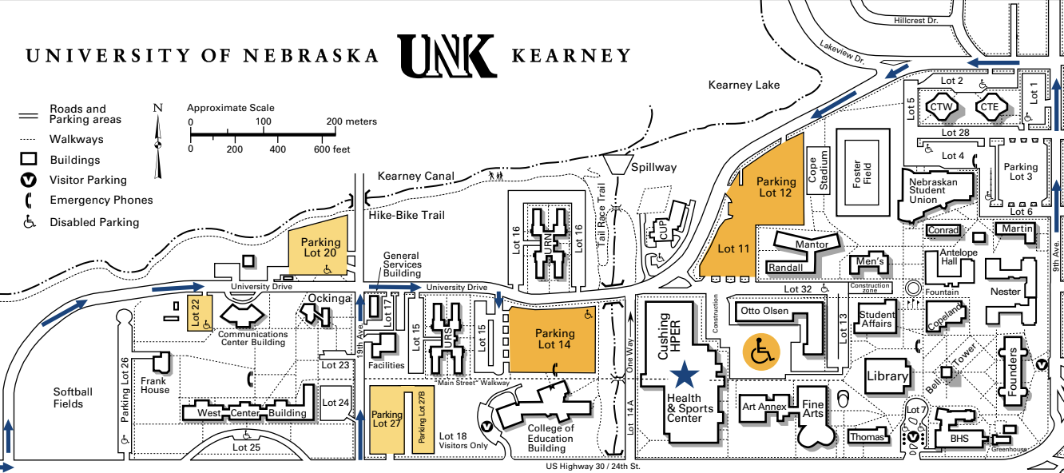

- Service Learning-PO & RS-HIGH STAKES-OCKINGA CONF 4. Improv Challenge-SHOWDOWN Copeland Hall

- Engineering Challenge-THRILL RIDE-Cushing (HPER) 5. Fine Arts Challenge-FLIP THE SCRIPT-Student Union (NSU)
Technical Challenge-PIECE BY PIECE—HPER GYM

- SOUVENIRS, STEAM ACTIVITIES & HOOPLA- ARENA FLOOR 6. Scientific Challenge-FAR-FETCHED-Student Union (NSU)
AWARDS CEREMONY-ARENA FLOOR

7. INSTANT CHALLENGE-WEST CENTER BUILDING

