

**Affiliate Finals**

**Saturday, April 2, 2022**

**Congratulations and Good Luck to all teams!**

**Important Tournament Reminders**

**Roll with It Challenge**- Report to weigh-in 1 hour prior to your scheduled Team Challenge Time.

**All Other Challenges** - Report to your site 20 minutes prior to your competition time.

**Souvenir** items are for purchase in the Health & Sports Center. Official DI Pins and Shirts and much more!

**Concessions** will be open in the Main Street area of the Health & Sports Center and in the Nebraskan Student Union.

All refreshments must be consumed in designated eating areas. **DI has no input on opening/closing times**

**No food/drink will be allowed in any of the competition areas.**

**ATM** is located in the atrium of the Nebraskan Student Union near the bookstore and convenience store.

**The Awards Ceremony** is tentatively scheduled for **4:00 p.m**. on the Arena Floor of the Health and Sports Center. We will begin the Ceremony as soon as the Score Room has verified all scores. **Join your team by your Challenge Banner** on the Arena Floor!

Take your **team picture by the Giant “DI**” in the main atrium all day!!!

**Lost and Found** is located at the Souvenir Booth!

All Challenge Sites have **First Aid Kits!**

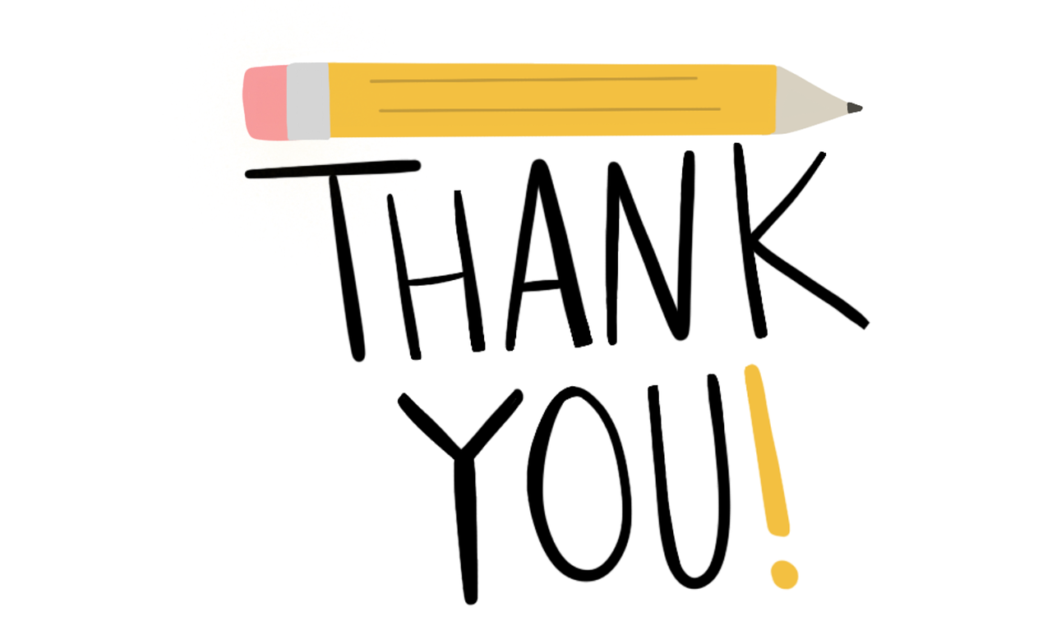

**UNK Campus**

Betsy Warren

UNK Custodial Staff

Volunteers

Parents

Team Managers

Appraisers &

NE DI Board of Directors



**NEBRASKA DI**

**We recognize everyone’s contributions and the diversity they bring.**

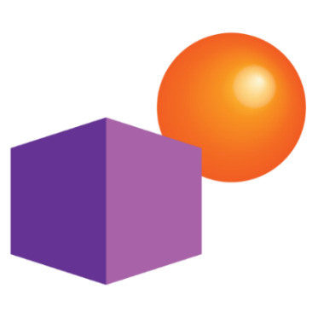

**DR. MARK A. RUNCO’S STUDY**

In 2014, Dr. Mark A. Runco, Professor of Educational Psychology for the Torrance Creativity Center at the University of Georgia and Board Member for the Center for Childhood Creativity, completed a study measuring student engagement and creative attitudes and values among students who participate in Destination Imagination and students who do not.  
**According to the statistically significant results, Destination Imagination students were found to be:**

* More engaged and imaginative when completing given tasks
* More creative than non-DI participants
* More self-confident and tenacious
* Able to elaborate on and generate more ideas than non-DI participants
* Great collaborators—86% of DI students agree that their teamwork skills improved within 1-2 years of participation
* More inquisitive—92% of DI students agree that solutions to problems are often improved by considering a variety of perspectives



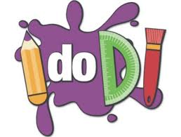



**Become a NEBRASKA DI Sponsor!**

Your sponsorship will support the Destination Imagination program in Nebraska and will help our kids!

Sponsorship can be financial and/or in-kind gifts or services. NCAPS will determine the acceptance of in-kind sponsorships on an individual basis. Sponsorships reset each year on November 1st.

**Friends of DI**

**I support Purple and Orange! $500 +**

Kim Bejot & Evan Evans

Donna & Dennis Robinson

Steffenie Brannon

**I support creative problem solving! $100-$499**

Beth Bogert

David & Roxie Boschult

Alan Danforth

**I support active learning! $50-$99**

**I support youth involvement! $1-$49**

Steve Taylor

George Blessing

**THE NE DI BOARD WISHES TO THANK YOU ALL FOR A FANTASTIC SEASON!**

**ONCE AGAIN, OUR KIDS ROSE TO THE OCCASION, NOT LETTING ANYTHING GET IN THEIR WAY-SEEKING SOLUTIONS AND CREATIVE ANSWERS TO ANY AND ALL CHALLENGES!**

**A JOB WELL DONE!**

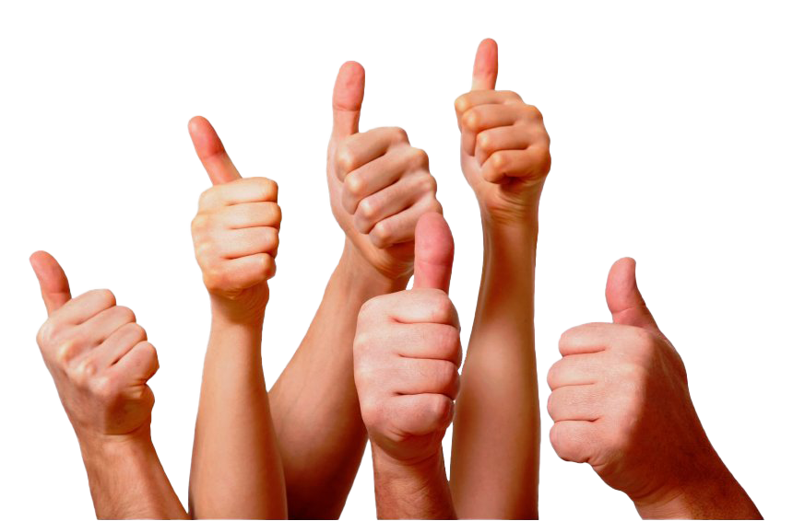

**LOOKING FORWARD TO SEEING YOU ALL NEXT YEAR TO CELEBRATE OUR**

**40TH ANNIVERSARY OF CREATIVE PROBLEM SOLVING IN NEBRASKA!**

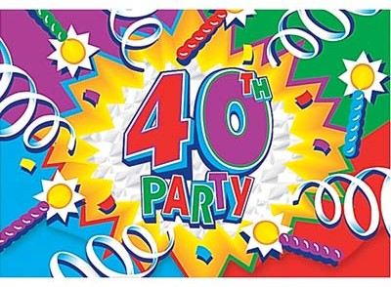

AFFILIATE FINALS WILL BE HELD APRIL 1, 2023!!

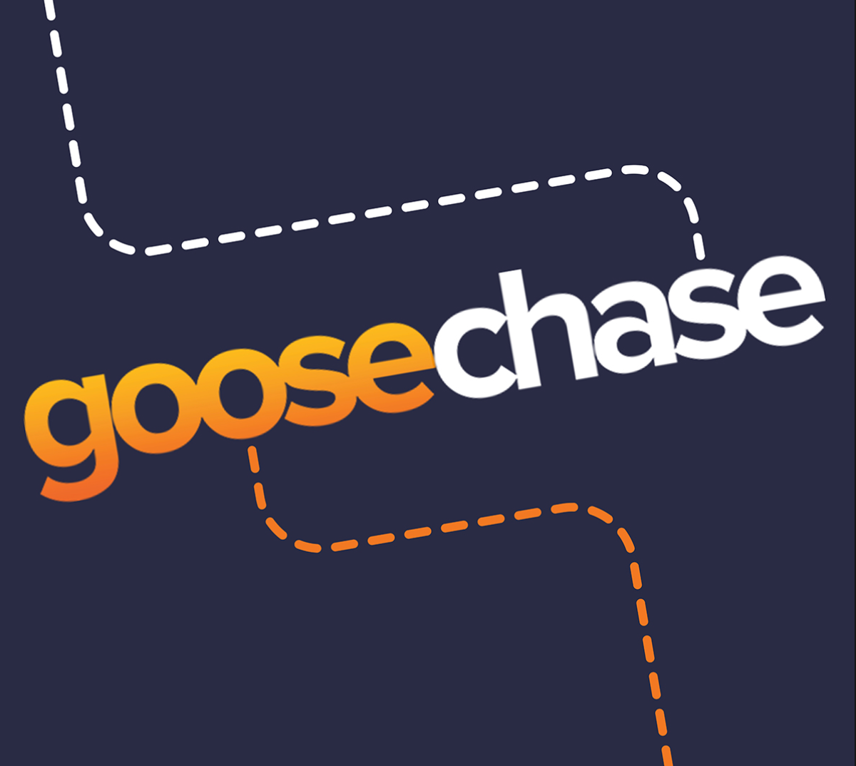

**ATTENTION--ALL TEAMS AT AFFILIATE FINALS!!!**

**Calling all creative problem solvers!**

**The Nebraska Destination Imagination Board of Directors is challenging YOU to a GooseChase!!!**

GooseChase is an online scavenger hunt we are hosting only at Affiliate Finals. To participate you need to download the GooseChase app from your app store on a device that is able to connect to the internet/data. Once you have the app downloaded search for a game using either the name of the game or the game code listed below. You can compete as a team or as an individual. There are a certain number of participants allowed for each game. If you try to join a game and it is full, try the next game.

**The password to enter any of the games is… creativity.**

**All games open at 8:00 a.m. and will end at 4:00 p.m.**

We would love for all of you to join and participate!

Let’s see how creative you all can be! Good luck!

**2022 NEDI Affiliate Finals Group 1: 4746KR**

**2022 NEDI Affiliate Finals Group 2: R368G9**

**2022 NEDI Affiliate Finals Group 3: VW1KK6**

**Game codes are case sensitive and only activated on April 2*