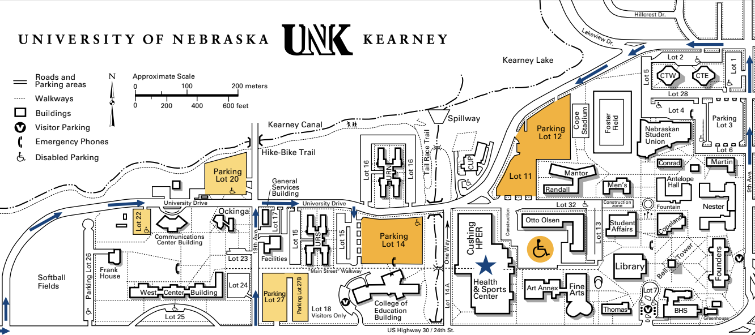

- Service Learning-PO & RS-FOR THE FUTURE-OCKINGA CONF 4. Improv Challenge-FESTIVAL FRENZY Copeland Hall

- Engineering Challenge-ROLL WITH IT-Cushing (HPER) 5. Fine Arts Challenge-TRICKY TALES-Student Union (NSU)

- Technical Challenge-DARING ESCAPE—ARENA 6. Scientific Challenge-UP CLOSE-Student Union (NSU)

INSTANT CHALLENGE-WEST CENTER BUILDING

